

DATA EXFILTRATION INVESTIGATION
This lab focuses on a suspected corporate data exfiltration incident involving M57.biz.

The Forensic Techniques And Tools Used
In this investigation, a forensic image of Jean’s computer hard drive and the spreadsheet file were analyzed the given files using Autopsy digital forensic tool. Here we analyze a forensic image of Jean’s computer hard drive and the spreadsheet file using the autopsy tool. The analysis process included examining file metadata, email communications, web activity, and system artifacts in order to identify the origin of the file, the method of transfer, and possible involvement of other employees.

The Evidence Discovered
The evidence discovered during the investigation is presented in multiple steps to clearly show how the file was located and how it was transferred.
Step 1:
Here we find the file of m57biz.xls and also the creation modified and access time. This evidence confirms that the spreadsheet existed on Jean’s system and provides important timeline information related to when the file was created, modified, and accessed.
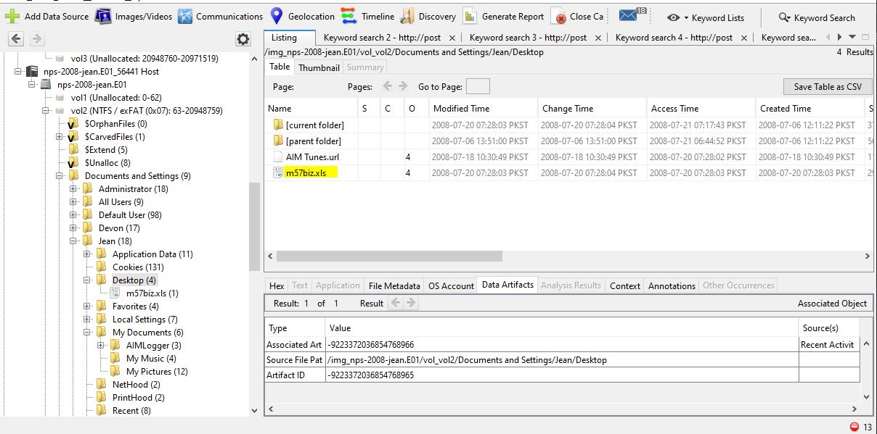
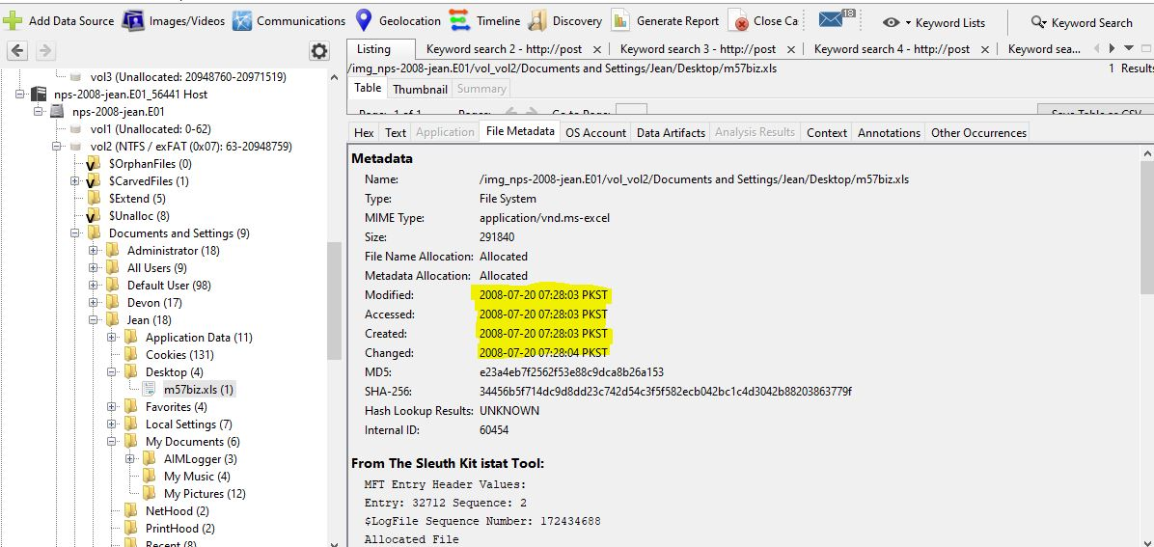
Step 2:
See here Jean send email to herself and also to the Alison which is president but Alison ask is not receive any email but he have receive the multiple emails. Email Investigation (Transfer Method). Here we in this Alison email have the attachment of the file whose sender is Jean and receiver is the Alison. And here we have open the attachment and here we see the attachment of the file is mbizxls but the Alison ask I have no receive any email of the this file means the Alison is ask lie here is the proof he receive the email. This email evidence shows that the spreadsheet was transferred through email and confirms that Alison did receive the file.
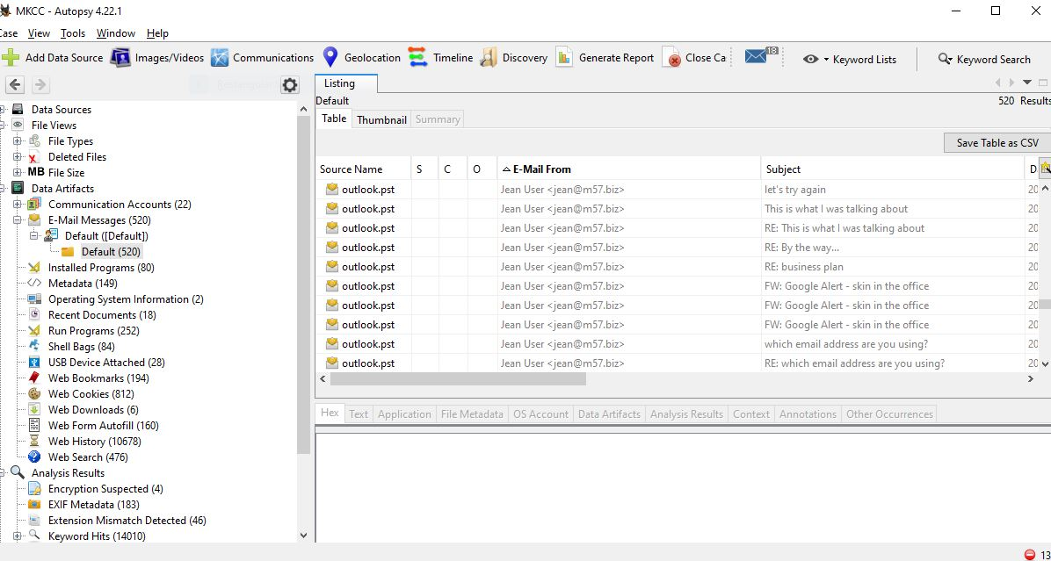
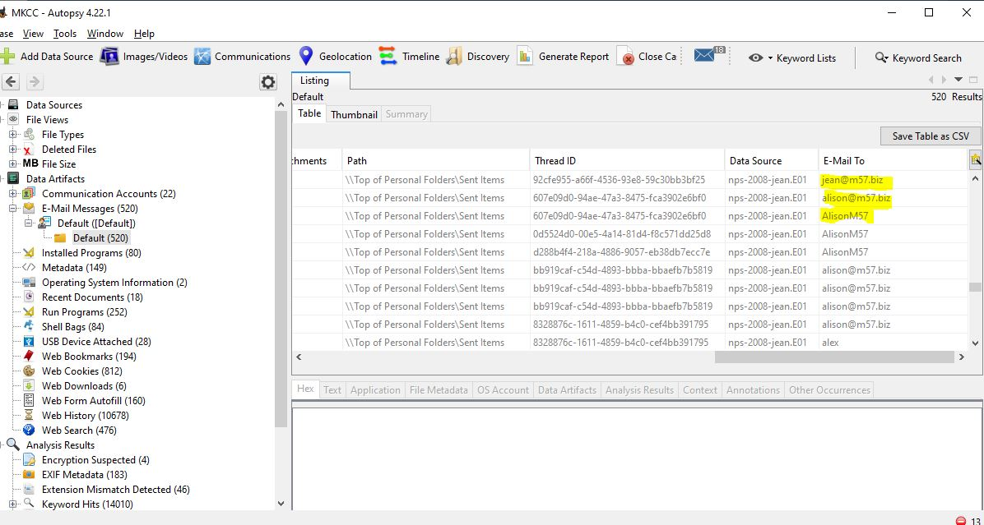
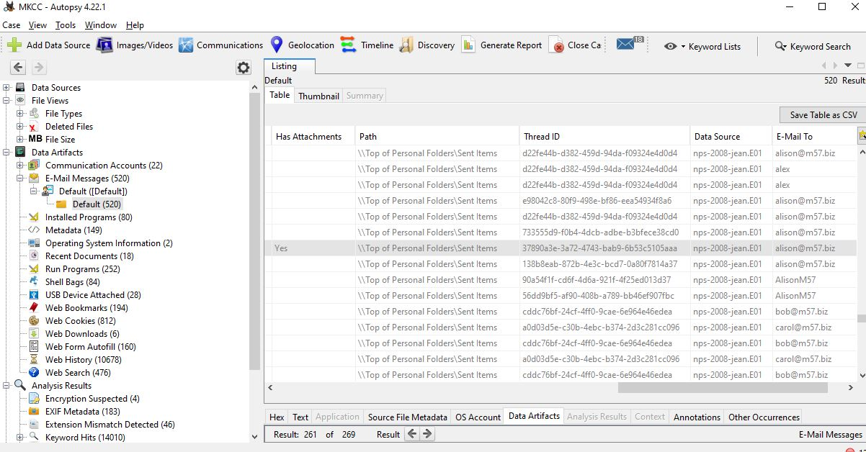
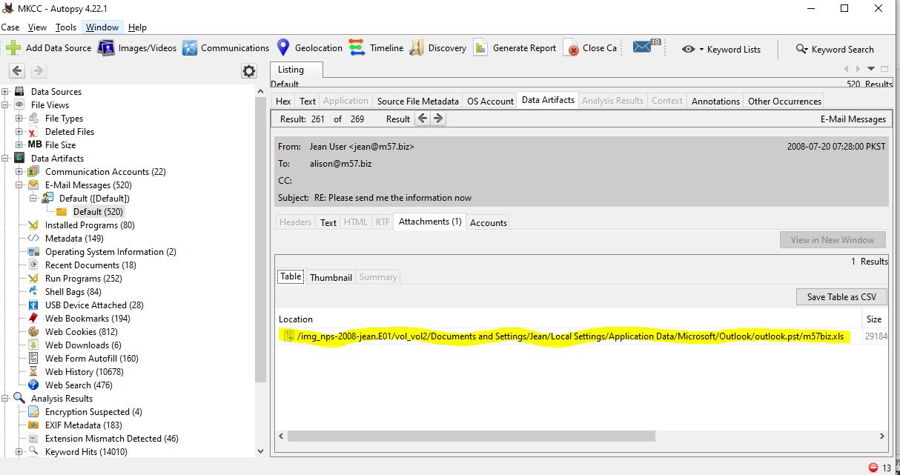
Step 3:
In July 18, 2008 at 7:20 AM activity perform from the Jean’s system. This activity save in the temporary internet save files in this Jean use the internet browser and this is 8 min before the file changes and access and the connection is the ebay and file finding from them competitor forum mostly user login through forum where his another session is active. In which have no any USB devices connect if the connect so the must show in the analysis result. Not found any another email where the m57plan.xls file send it. This evidence indicates browser usage close to the file access time and rules out USB-based data transfer.
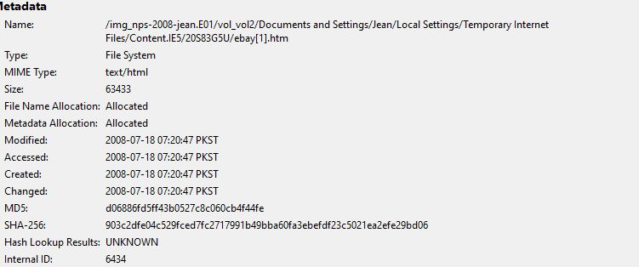

The Reasoning That Supports Conclusions
This investigation looks at all the evidence we found. The file information shows that the spreadsheet was on Jean’s computer. Email evidence shows that Jean sent the file to Alison, which goes against what Alison said. Web activity right before the file was changed and opened shows that the file might have been accessed online. No USB devices were found and no other emails with the file were found, so it seems that no other ways were used to move the file, and no other employees were involved.
Deliverables
The deliverable for this investigation is a complete forensic report following the outline provided. This report includes all the important parts, like the tools and methods used, the evidence we found, and the reasoning that supports the conclusions. It gives a clear and organized presentation of the analysis done on Jean’s computer and the spreadsheet, showing all findings clearly for review and submission.

